**Varistors**

Varistors, also called metal-oxide varistors (MOVs), are used to protect sensitive circuits from a variety of overvoltage conditions. Essentially, these voltage-dependent, nonlinear devices have electrical characteristics similar to back-to- back Zener diodes.

**Why to use MOV**

• Inductive-load switching: When the inductive load is switched off, the collapsing magnetic field converts into electrical energy, which takes the form of a double exponential transient.

• Electrostatic discharge (ESD): This energy is the result of an imbalance of positive and negative charges between objects. It’s characterized by very fast rise times and very high peak voltages and currents.

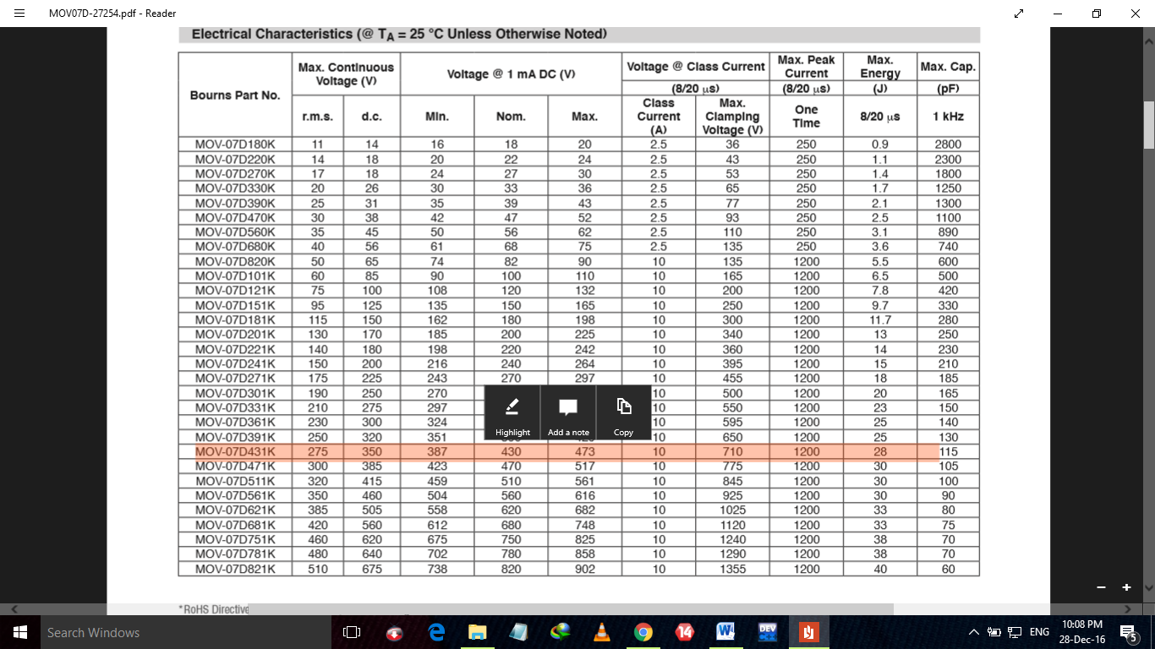

**FUSE**

What is the normal operating current of the circuit?

In order to select the right amperage of the fuse, you first need to know the full-load steady-state current of the circuit at an ambient temperature of 25º C (68º F). Once the current value is determined, then a fuse rating should be selected as to be 135% of this value (taken to the next standard value).

For example, if the normal steady-state current is calculated to be 10 amps, then a 15A fuse rating should be selected [10 amps x 135% = 13.5 amps, the next larger standard size is 15A].

It is important to note that if the fuse is intended to be used in an environment with possibly very high or low ambient temperatures, then the nominal fuse current would need to be sized significantly higher or lower (see ambient temperature below).

What is the operating voltage?

The basic rule of thumb is that the voltage rating of the fuse must always higher than the voltage rating of the circuit that it is protecting.

For example, if the circuit voltage is 24 volts, then the fuse voltage rating must be higher than 24 volts (yes...it can be 250 V...just so long as it’s higher than the circuit voltage)

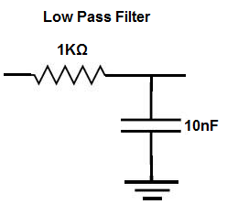

The formula to find the frequency cutoff point of an RC circuit is, frequency= 1/2πRC. Doing the math, with the values shown above, we get a frequency of, frequency= 1/2πRC = 1/2(3.14)(1KΩ)(10nF)= 15,923 Hz, which is approximately 15.9KHz.

This means that all frequencies above 15.9KHz are attenuated. And as you get further (higher) from the 15.9KHz region, the attenuation becomes greater and greater.

Frequencies below 15.9KHz are passed through without attenuation.

So if we input an AC signal into the circuit from the function generator and place the signal to a low frequency signal such as 10Hz, the circuit will pass this signal to output almost completely unattenuated. This is because low frequency signals do not take the path of the capacitor. You can check this if you have an oscilloscope. If you now increase the frequency of the signal to 30KHz, the signal will pass through to output with great attenuation. This is because high frequency signals go through the capacitor and not to output, because capacitor is low resistance to them.

+++++++++++++++++++++++++++++++++++++++++++++++++++++++++++++++++++++++++++++++++++++

PIV for rectifier diodes = Vm-Vf

